1. Let’s clear database.
2. **NOTE**: Whenever you want to add or delete documents, they are performed on collections so 🡺 db.collectionName.thenCommand.
3. **Command** 🡺 Db.flightData.deleteOne(filter, options);
   1. Filter: document.
4. Db.flightData.deleteOne()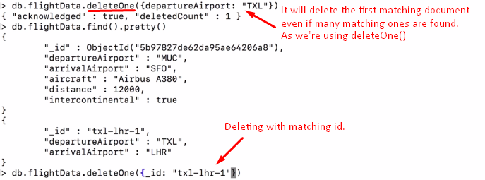
5. 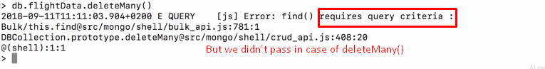
6. **NOTE**: When deleting, **query criteria** is necessary to pass. No matter if you call deleteOne() or deleteMany()
7. **Error while updating document** and solution  
   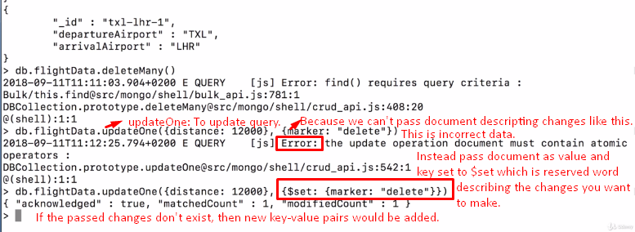  
   command🡺 db.flightData.updateOne({distance:12000},{$set:{marker: “delete”}})
8. **Updating all documents in a collection**: 
9. **Deleting all documents from a collection:**